1.Unzip zipped file and copy them onto a SD card；insert the SD card into the GPS card slot of the unit
2.Turn on the unit, follow these steps: settings-About tablet-MCU update

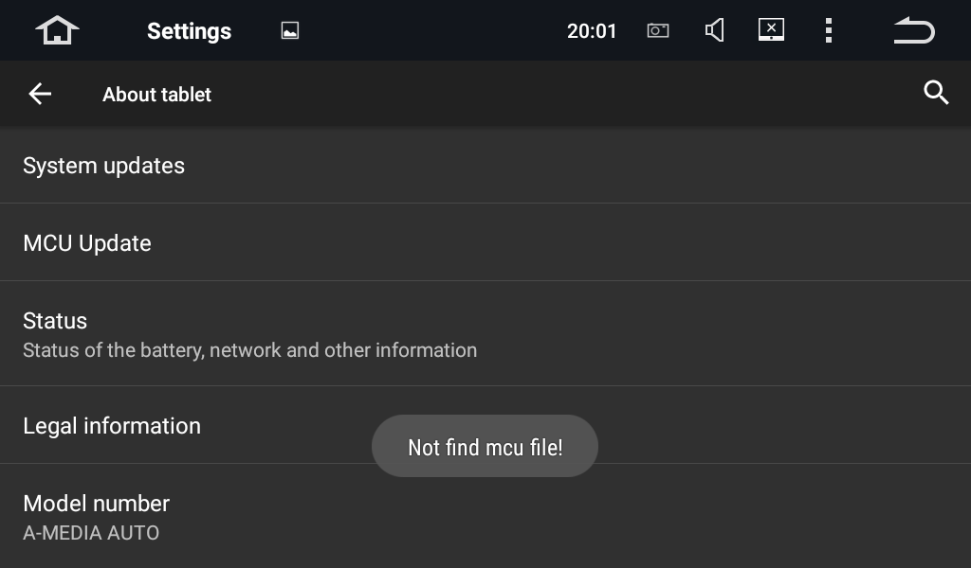

3.The unit will be into update mode automatically after the “MCU update” is selected

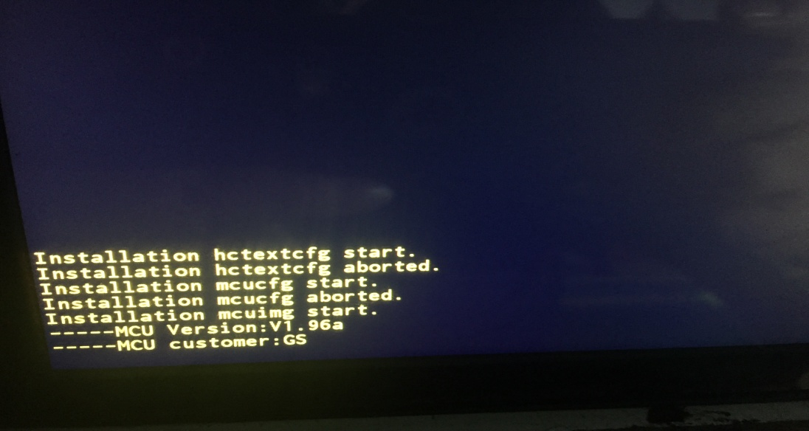
The unit will restart after the update is completed

4.Follow these steps after the unit is turned on: settings-about tablet- System updates
The unit will restart after the update is completed
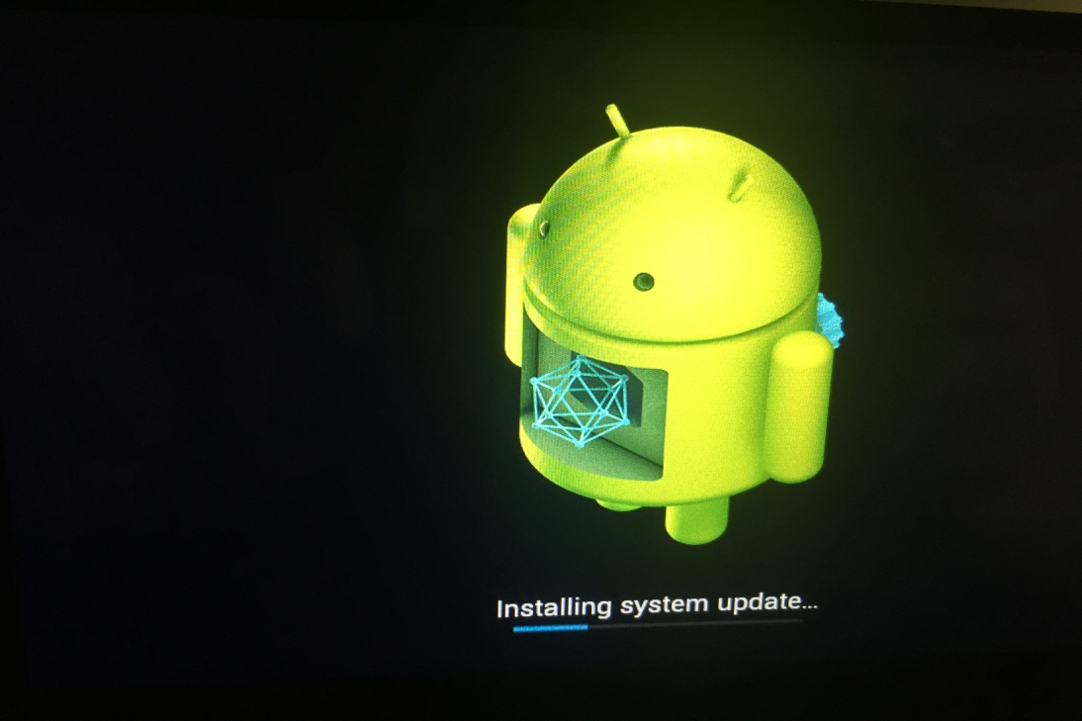

If we can’t access to update option in settings, try to update via GPS card slot

1.Press the reset button(For the unit with touch panel, insert a pin into the tiny reset hole;For the unit with hard buttons, press the power button instead) for 5-10 seconds until the unit is into the update mode as below:
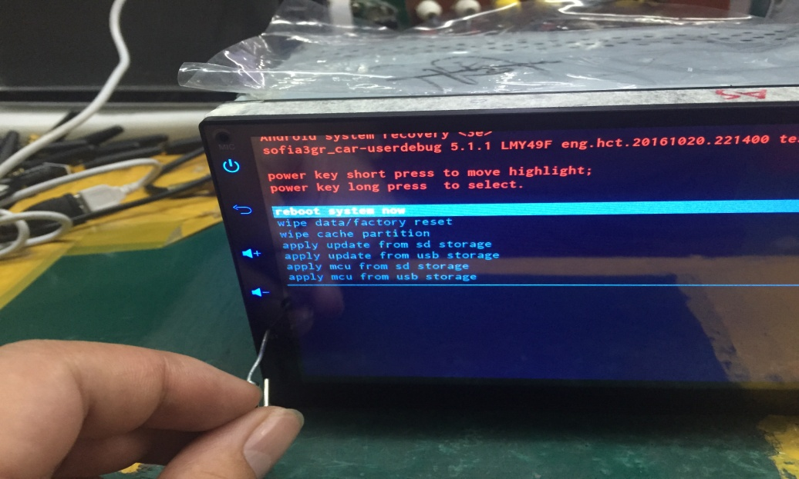
2.Select” apply MCU from SD storage” ( 1 press of the reset button to select, long press to confirm):
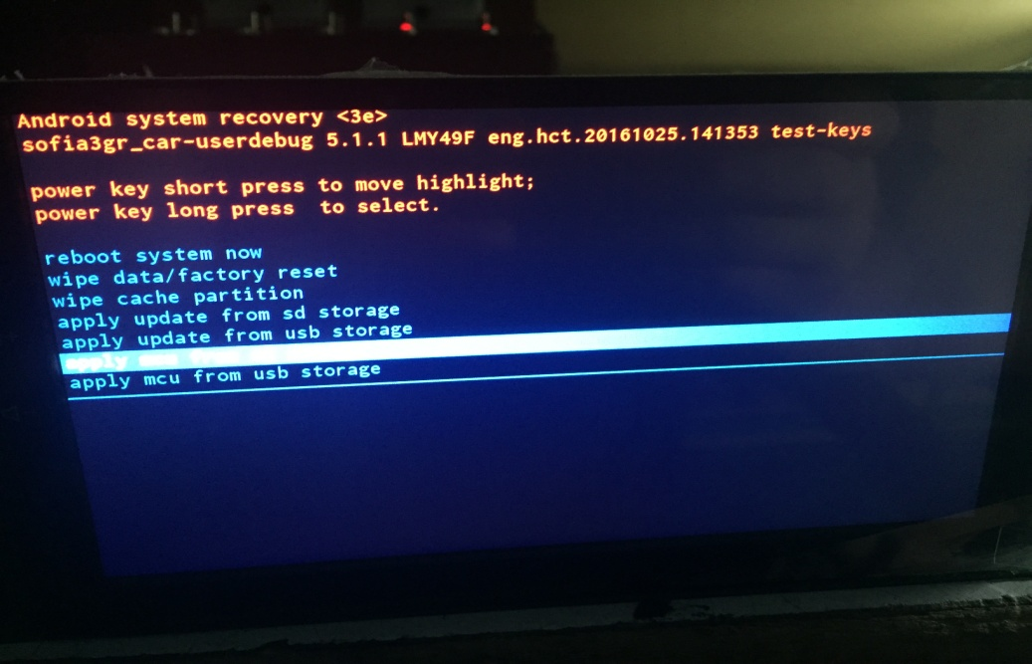
The update will start as below:

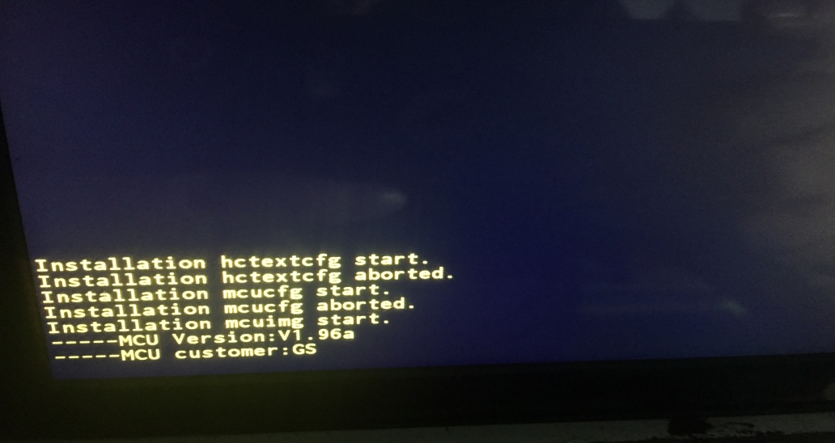
The unit will restart after the update is completed.
3.The steps are the same for system update shown as below:
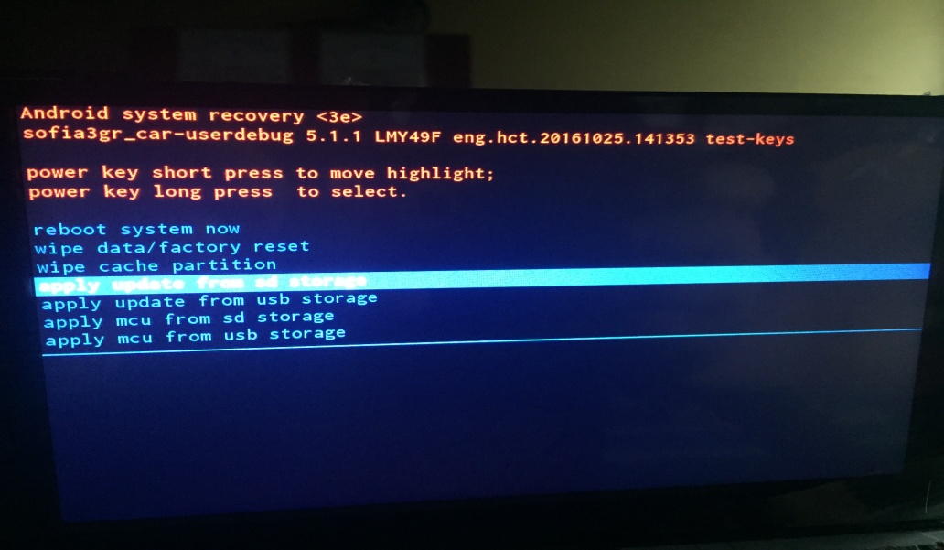
After “ apply update from SD storage” is selected, select” UPDATE.ZIP” in the interface below:
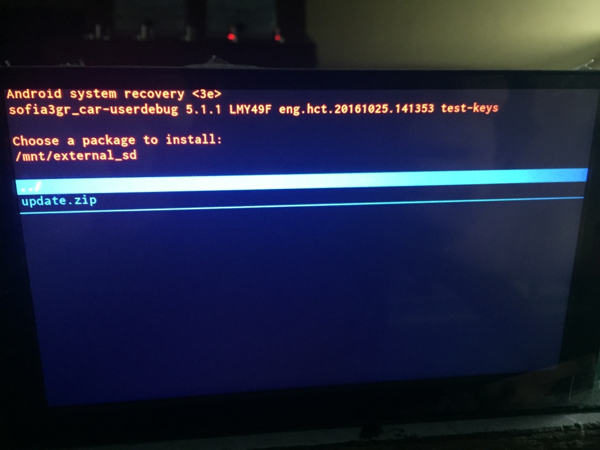

4.The update will start as below:
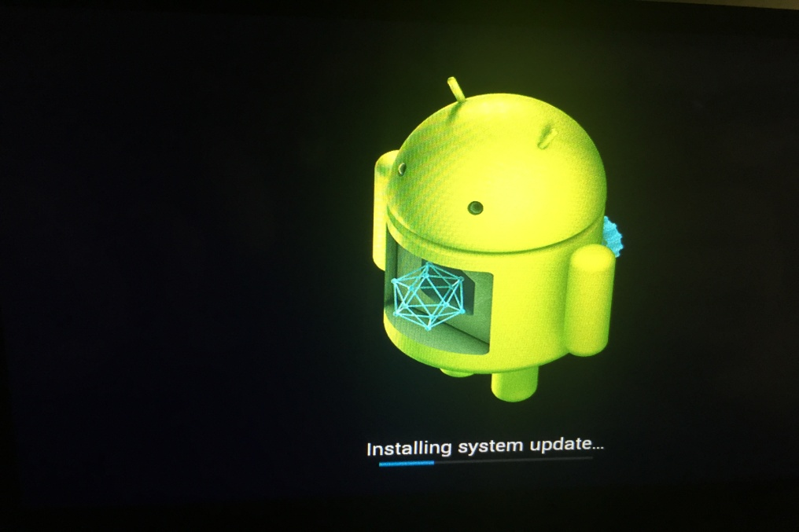
The unit will restart after the update is completed
If the unit won’t turn into the update mode, we can simply select” reboot system now” to reset the unit

